**Grammarly**

[*Grammarly*](https://www.grammarly.com/)is an “AI writing partner that helps people at every stage of the writing process from blank page to final draft” (Grammarly, 2024a).

Please check that you will be able to use the tool by [*checking the system requirements*](https://support.grammarly.com/hc/en-us/articles/4412835748877-What-are-the-system-requirements-for-Grammarly-for-Windows-and-Grammarly-for-Mac)*.*

This guide will focus on using Grammarly as a proofreading tool (available in both the free and premium versions) so that you can “catch typos, missing punctuation, or commonly confused words” (Grammarly, 2024b). Using Grammarly in this way will not be picked up by the AI Turnitin tool “Our detector is not tuned to target Grammarly-generated spelling, grammar and punctuation” (Grammarly, 2024c),

We suggest that you do not need to purchase the premium version as using Grammarly for proofreading will involve turning off the Generative AI component of the product. Therefore, you will not be maximising the tool's features you are paying for.

If you have a Support and Development plan, you may have access to other features but may also find the information below, helpful.

This guide should be read in conjunction with our other resources on Generative AI.

**What is proofreading?**

Proofreading is checking the final draft for errors in formatting, spelling, grammar, punctuation, word use, and referencing.

***Important Note***

*If you don’t want to use an AI writing tool to do this, you have other options such as:*

* *Using the Editor function in Word.*
* *Reading and acting on advice in our Proofreading Your Work self-study guide.*
* *Using Studiosity.*
* *Reading and acting on advice in our Good Academic Style self-study guide.*

**When to use Grammarly when writing**

Firstly, you need to **establish if you can use Grammarly.**

***Important Note***

*It is vital that you refer to and follow the guidance provided by your programme and/or module and to read your assignment briefs carefully. The assignment brief should provide information on any specific requirements for how you are expected to engage with and acknowledge (Gen) AI for any assessed work. For example, you may be asked to use or not to use specified (Gen) AI tools depending on what the module is seeking to assess.*

Secondly, remember that although Grammarly can be really useful, it is not a knowledgeable human. It bases its suggestions on algorithms, without knowing anything about your subject or what you intend to say. As such, **it may hallucinate (make mistakes and miss things)**. You should always use your own understanding and critical thinking to check. Make use of the Critically evaluating Gen AI guide.

* Technical words from your subject area – If a word is not in Grammarly’s dictionary, it is likely to come up with an incorrect suggestion; for example, “unitarist”, a term used in management may be corrected to “guitarist”.
* Words that could be correct in a different context – Grammarly might not notice, for instance, if you wrote “the cat was red” when you meant to write “the cat was *fed*” or “the cat *is*red”.

**Setting up Grammarly**

Once you have set up and logged into your account, to use Grammarly as a proofreading tool, switch off the Gen AI component.

Click on Account from the left-hand side of the webpage. Then click on Settings and in the list that appears, click on Feature customization. Click on the ticks to disable all aspects of the Generative AI feature. The image below shows how this setting should look once disabled.

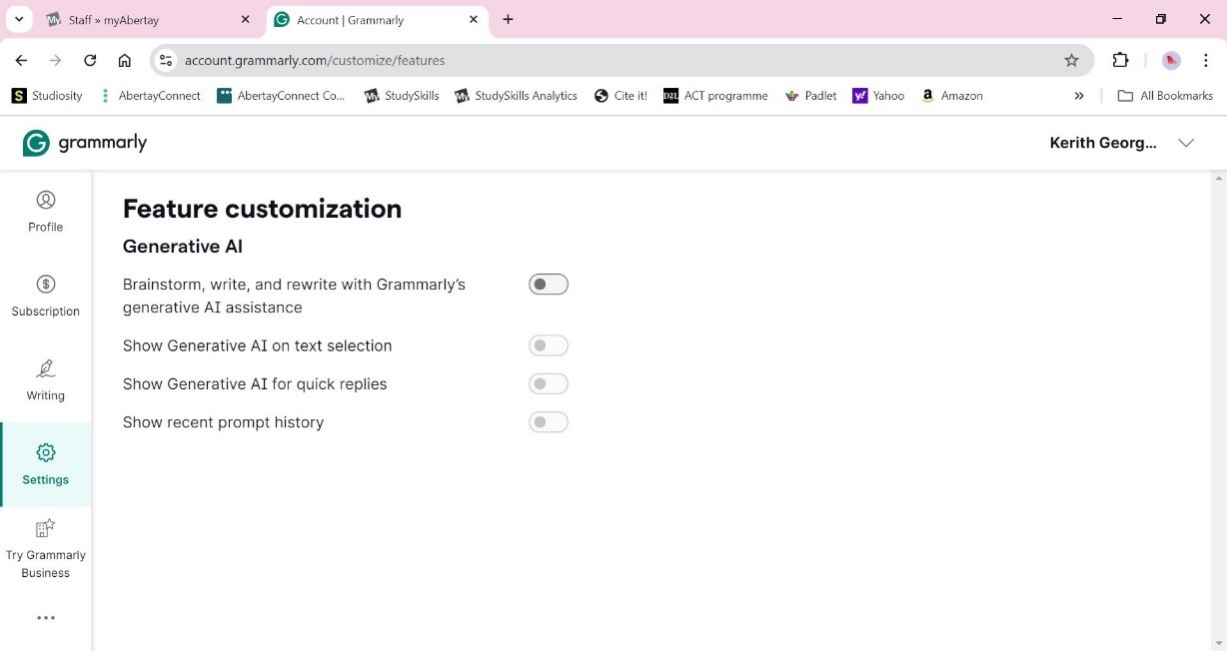

*Grammarly – turning off AI*(2024) [Screenshot]. Available at: https://account.grammarly.com/customize/features (Accessed: 05 August 2024)

You can then head back into your account and add information to your profile. If you click on writing on the left-hand side of the webpage, you can select your dialect (the choice is limited). Selecting British English or American English will help you maintain a consistent style.

**Working in One Drive**

Before engaging with Grammarly familiarise yourself with saving your work on One Drive before starting to proofread your work (with Grammarly or any other tool). It is important that you keep a record of your drafts. Keeping records of your drafts serves as documentation of your writing process and proof of the authenticity of your work. Saving drafts is easy to do with One Drive as it keeps a record of your 'version history.'

**Using Grammarly**

Choose how you want to work with the tool (the information below refers to the free version of Grammarly).

The **first approach** is to have it [*running on your desktop*](https://www.grammarly.com/desktop). The advantage of this is that you will see suggestions as you type any text on your computer so it will also pick up language errors when you are writing emails, for example.

You can click on the word that has been underlined and see a suggestion or, and we **recommend this**, click on “see more in Grammarly” and you’ll have a list of suggestions pop up. This now allows you to click on the i button and receive an explanation for the error. See the image below for where the i button is located.

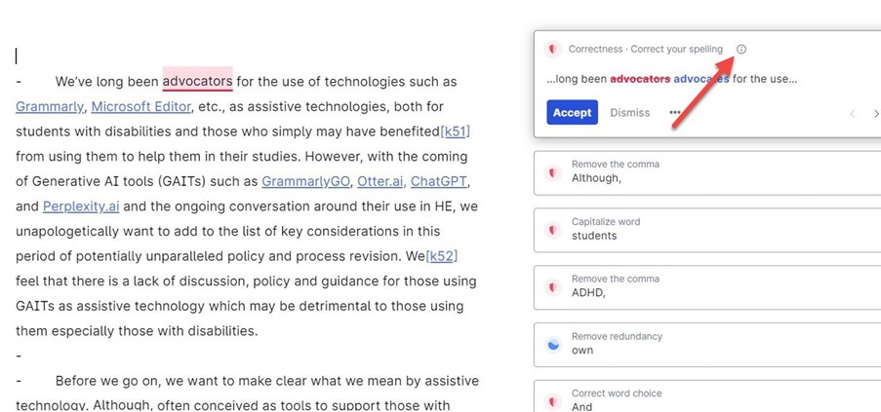

*Grammarly AI in action: explanations*(2024) [Screenshot]. Available at: https://app.grammarly.com/ddocs/2152644775 (Accessed: 05 August 2024)

**The second option** is to [*log in/sign in to your Grammarly account*](https://www.grammarly.com/signup). The advantage of this is that you can set the ‘language’ goals for your draft.

Once logged in, you will see a New/Upload rectangle. Click on the word upload and select the document you have been working on.

As your document appears, the review suggestions may appear automatically on the right-hand side of the page. However, if they do not, in the top right-hand corner of the screen, click on the green button**correct with assistant**.

Now, you can see the word Goals – click on this and select what is appropriate for you.

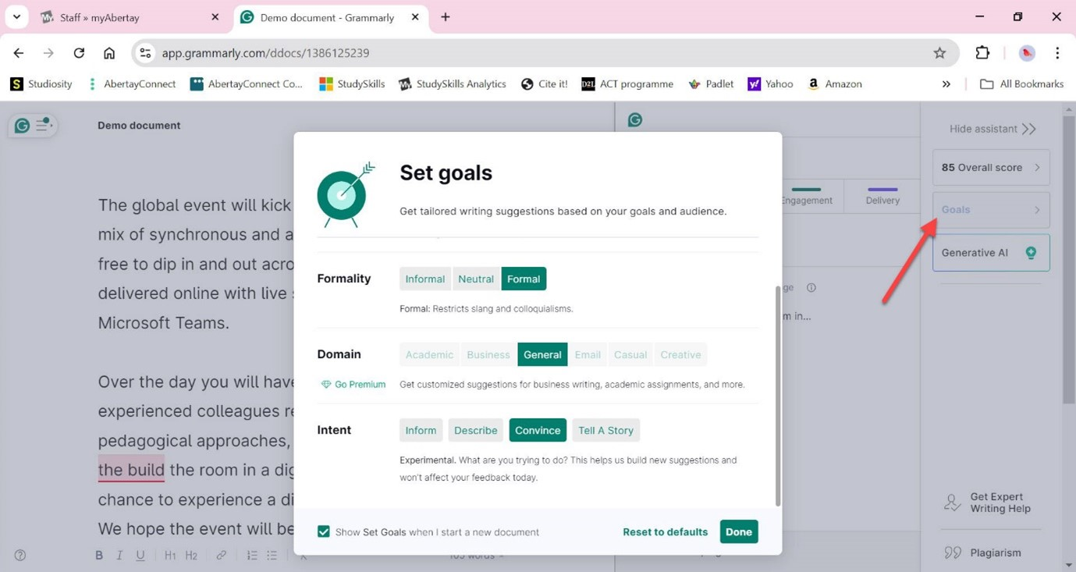

*Grammarly AI in action: goals*(2024) [Screenshot]. Available at: https://app.grammarly.com/ddocs/1386125239 (Accessed: 05 August 2024)

You can also click on the ?  symbol at the bottom left-hand side of the webpage (arrow in image below indicates where its located) and make the font bigger and use colorblind mode.

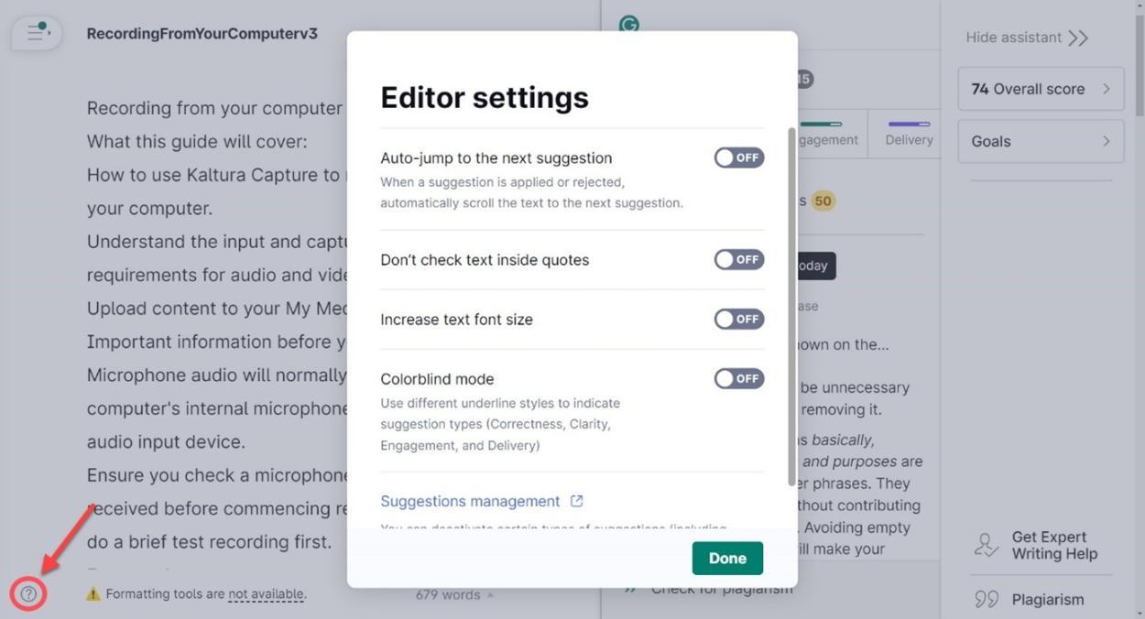

*Grammarly AI in action: editor features*(2024) [Screenshot]. Available at: https://app.grammarly.com/ddocs/2339456324 (Accessed: 05 August 2024)

**Grammarly's free AI Paragraph Rewriter**

You may come across [*Grammarly’s free AI Paragraph Rewriter tool*](https://www.grammarly.com/paragraph-rewriter). This is separate from the tool we have been discussing above and should NOT be used unless specifically allocated this tool as part of a Support and Development Plan.

“Spinning” (getting AI to rewrite the content of your paragraphs/drafts) does not demonstrate [*Good academic practice*](https://intranet.abertay.ac.uk/students/study-skills/guides/getting-started/good-academic-practice/) and is likely to be picked up by Turnitin’s AI writing and paraphrasing capabilities tool.

***Important Note***

*Turnitin has upgraded its AI writing detection feature to include a new paraphrasing detection capability.*

*The report will highlight text that Turnitin’s model predicts was modified using an AI paraphrasing tool.*

**Acknowledge the use of the proofreading features of Grammarly in your work**

No, as you have turned off the Generative AI component and have only used the proofreading features, you do not need to acknowledge the use of Grammarly.

However, you should read the guide on Acknowledging the use of AI if you turn on the Generative AI component. By acknowledging your use of the Generative AI component you are demonstrating good academic practice and complying with the terms and conditions of Grammarly which state you may not use its product to “mislead any third party that any output from Grammarly’s generative AI was solely human generated” (Grammarly, 2024d).

**Reference List for Sources referred to in the creation of this document**

Grammarly (2024a) *Our Mission*. Available at: [*https://www.grammarly.com/about*](https://www.grammarly.com/about) (Accessed: 02 August 2024).

Grammarly (2024b) *Features*. Available at: [*https://www.grammarly.com/features*](https://www.grammarly.com/features) (Accessed: 02 August 2024).

Grammarly (2024c) *Turnitin's AI writing detection capabilities FAQ*. Available at: [*https://guides.turnitin.com/hc/en-us/articles/28477544839821-Turnitin-s-AI-writing-detection-capabilities-FAQ*](https://guides.turnitin.com/hc/en-us/articles/28477544839821-Turnitin-s-AI-writing-detection-capabilities-FAQ)(Accessed 13 August 2024).

Grammarly (2024d) *Terms of Service*. Available at: [*https://www.grammarly.com/terms*](https://www.grammarly.com/terms)  (Accessed: 05 August 2024).

Turnitin (2024) *Turnitin’s AI writing and paraphrasing detection available now*. Available at: [*https://www.turnitin.com/solutions/topics/ai-writing/*](https://www.turnitin.com/solutions/topics/ai-writing/) (Accessed: 02 August 2024).

**Not feeling confident yet?**

Don’t worry! Email [studyskills@abertay.ac.uk](mailto:studyskills@abertay.ac.uk). We are here to help!

Grammarly © 2024 by Abertay University is licensed under [Creative Commons Attribution 4.0 International](https://creativecommons.org/licenses/by/4.0/?ref=chooser-v1)